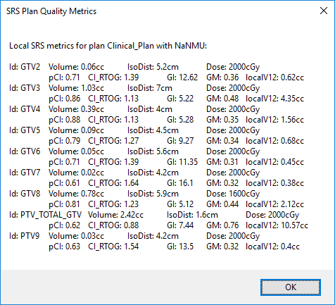

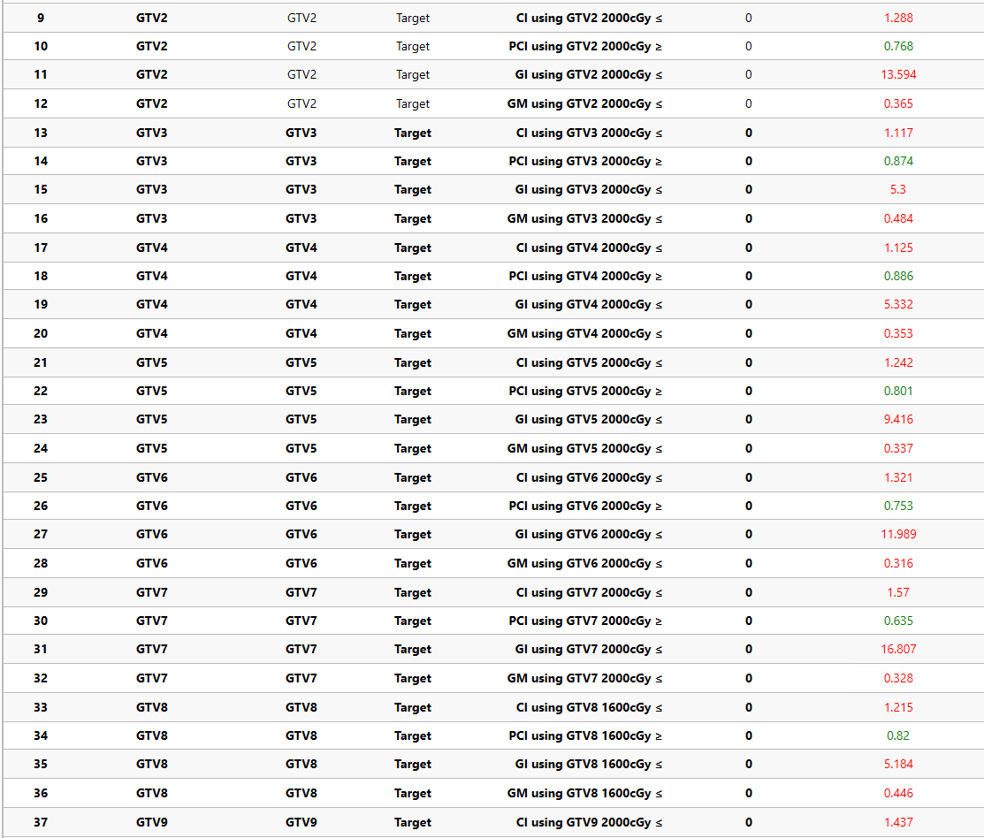



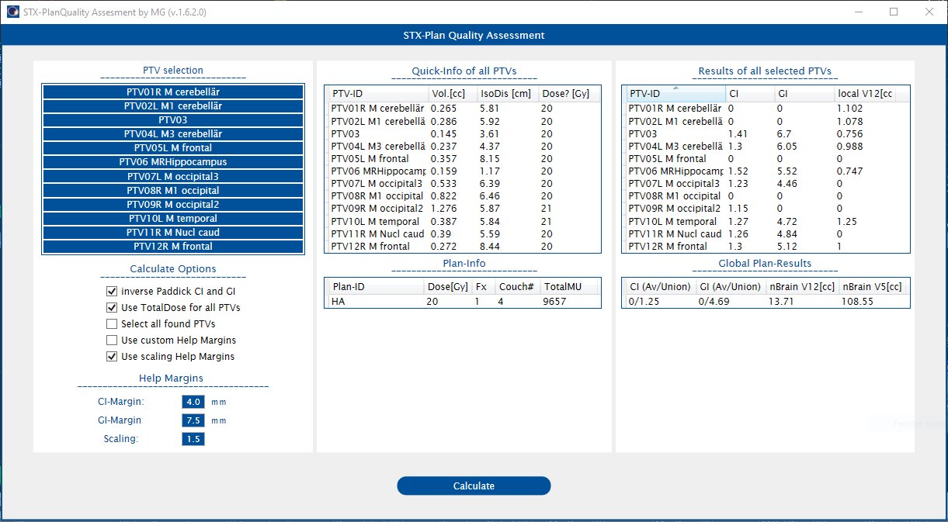

Brainlab elements

<https://userguides.brainlab.com/en/guides/multiple-brain-mets-srs/en/2.0/okh1544542230751-50/>

Eclipse

<https://www.ncbi.nlm.nih.gov/pmc/articles/PMC5718686/>

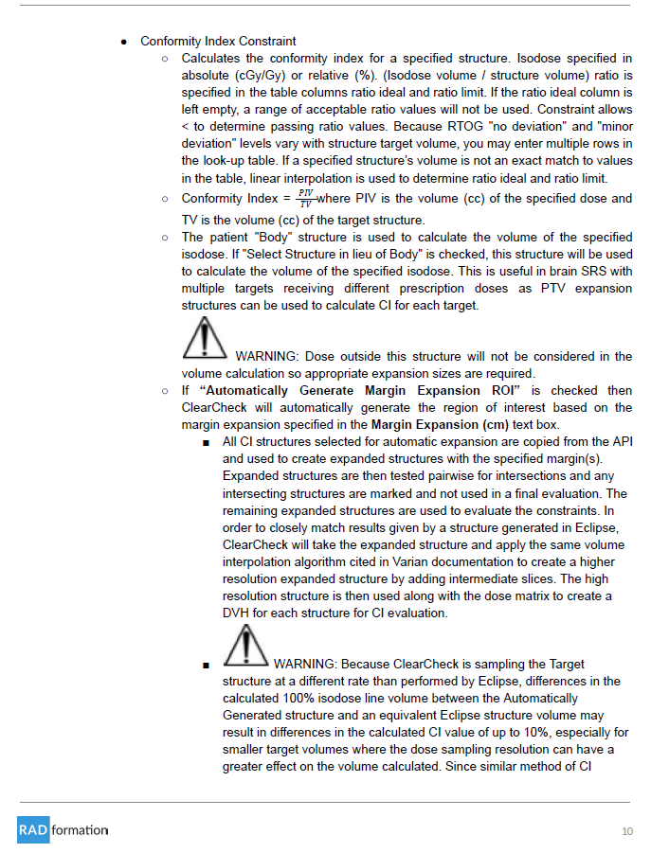

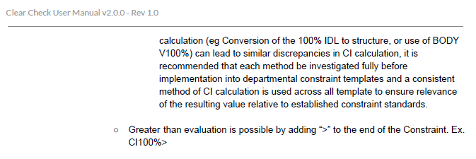

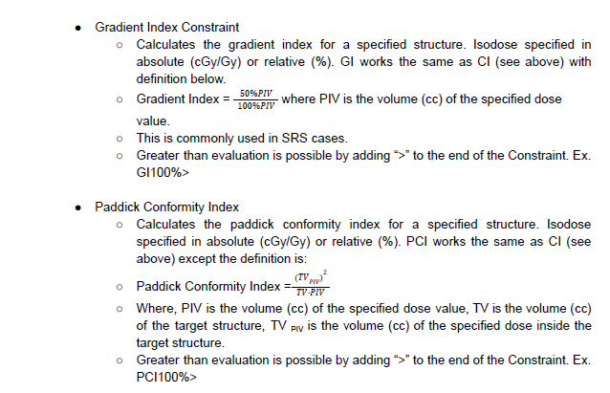

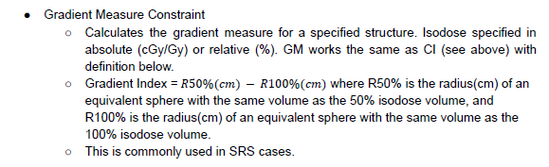

RTOG 0813 (Lung)

